

SpRINT 2 Plan

# Subin Jeong, Joowon Lim, Hakyeong Kim, Tim Burkhart, mitchell etzel

Product Name: Haru (하루)

Team Name: One Day

Sprint Completion Date: 07/18/2016

Revision Number: 3

Revision Date: 07/18/2016

# Sprint Goal:

As a team we want to further the development of our system prototype so that we can provide users with the promised usability of a daily dairy app that tracks your GPS location.

# Task listing

1. As an app manager, I want to draw tracks on the map to provide the user with the ability to see a daily path of where they went throughout their day. (13)
   1. Create a Template to save the GPS location and time spent there (4 hours)
   2. Automate how application keeps track of info throughout the day (6 hours)
   3. The track color will gradually change as the time pass. (4 hours)

Estimated time: 10 hours

1. As a user, I want to add comments to my daily track so that I can record my feelings and activities at the given time and location. (8)
2. User can view a page that brings all the comments of a day together. (3 hours)

Estimated time: 3 hours

1. As an app manager, I want to save the daily track and pins that are generated so that the user can keep track of more than one day at a time. (5)
2. Connect to SQLite Database (3 hours)
3. Create Template to Save Daily Track + Pin Data Together (4 hours)

Estimated time: 7 hours

1. As a user, I want a User Manual so that I can understand how Haru works. (3)
2. Create Template User Manual (2 hours)
3. Update Template as New Functionality is added (1 hour)

Estimated time: 3 hours

1. As an app manager, I want our team to follow the Continuous Integration Practice so that we can gain a better understanding of what it will take to integrate our work together. (3)
2. Create a method to share our work with the team even if it’s 100% (1 hour)
3. Upload your work before SCRUM meetings (1 hour)

Estimated time: <2 hours

# TEAM ROLES & TASK ASSIGNMENTS

Subin Jeong(Product owner) : 2.c 4.b 5.a 5.b

Hakyeong Kim(Scrum master) : 3.a 3.b 5.a 5.b

Joowon Lim(Designer owner) : 1.c 4.b 5.a 5.b

Tim Burkhart(Producer) : 1.a 5.a 5.b

Mitchell Etzel(Producer) : 1.b 4.a 5.a 5.b

# Initial burn-up chart

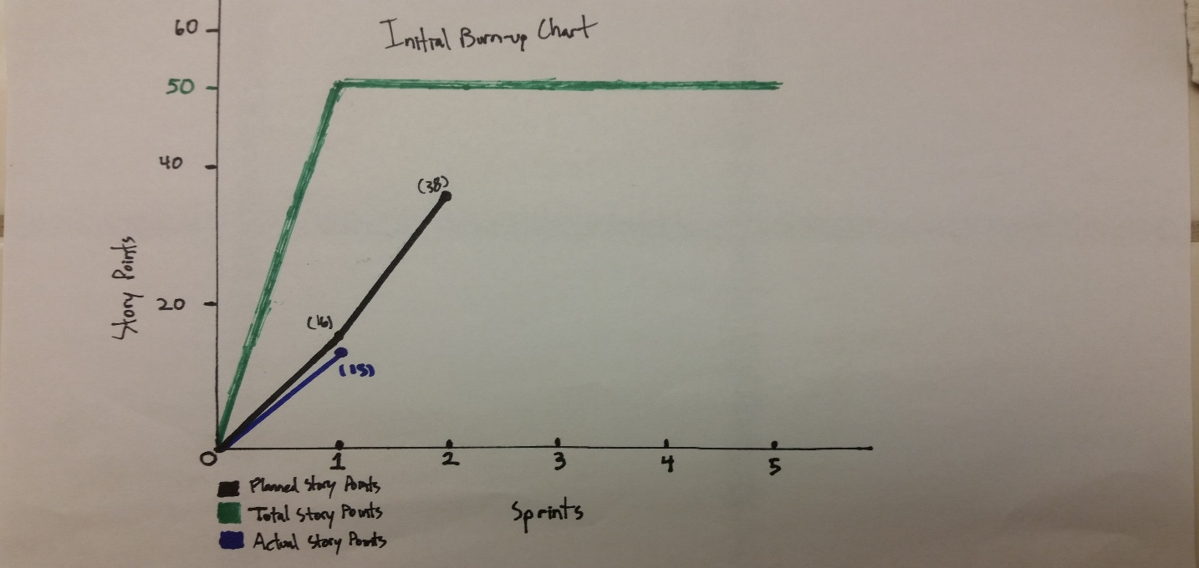

# Initial SCRUM Board

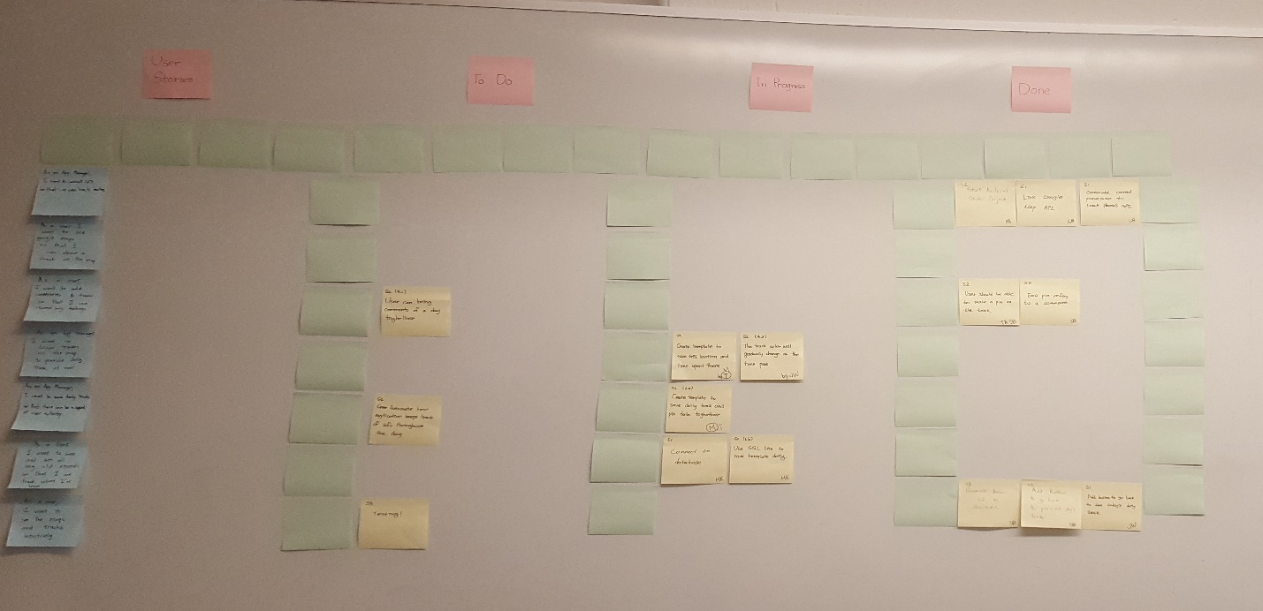

***Final Drafts Available in BSOE 316***